**Slide 1 - Slide 1**

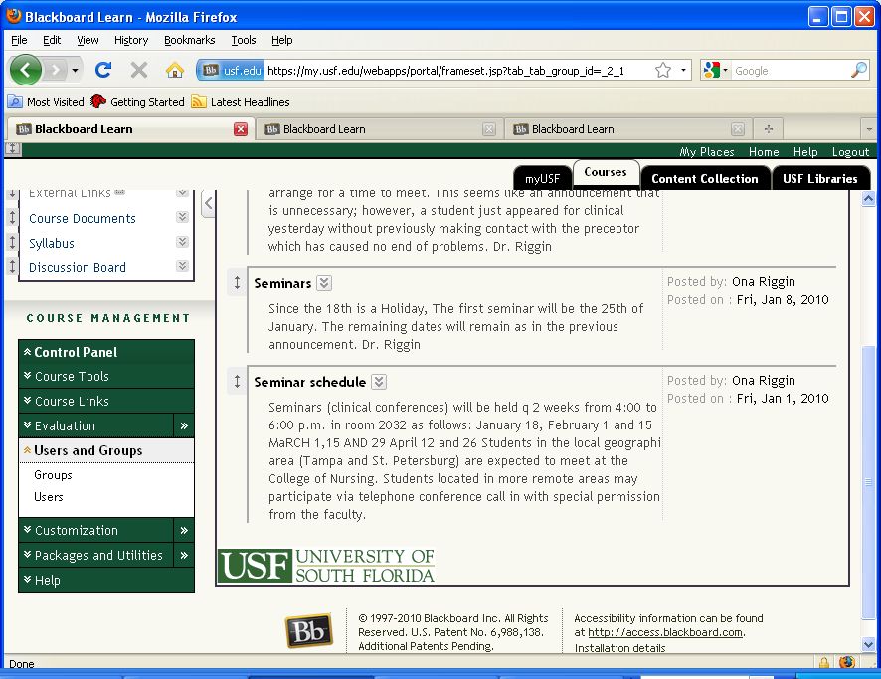

**From the Control Panel>Users and Groups option, select Users.Slide 2 - Slide 2**

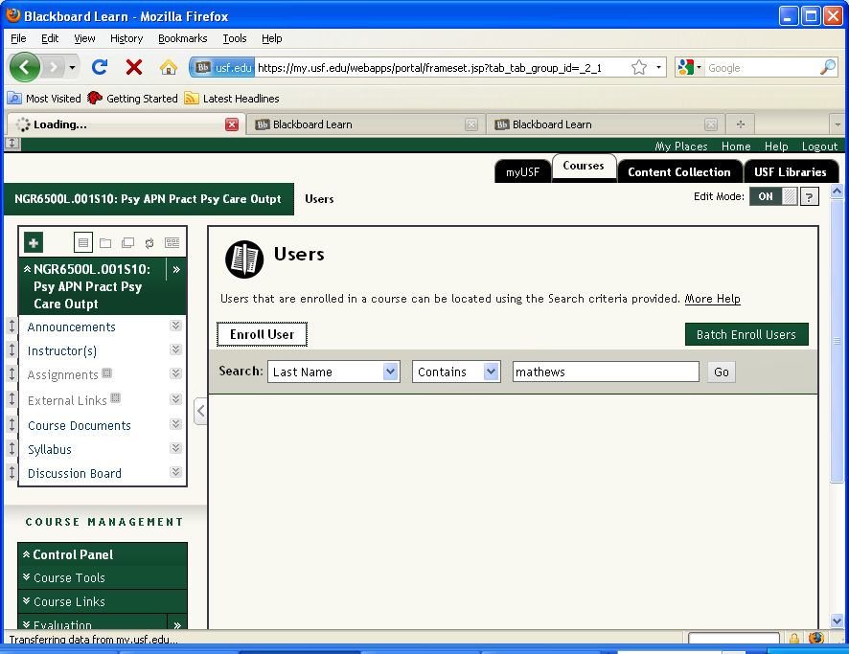

**To enroll studentsor faculty, click the Enroll Users button.Slide 3 - Slide 3**

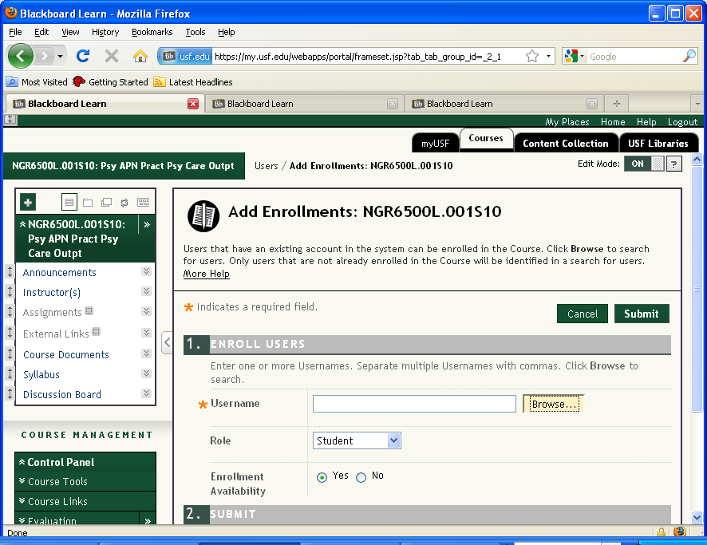

**If you know the person’s USF Net ID, you can enter it here, otherwise, click Browse.Slide 4 - Slide 4**

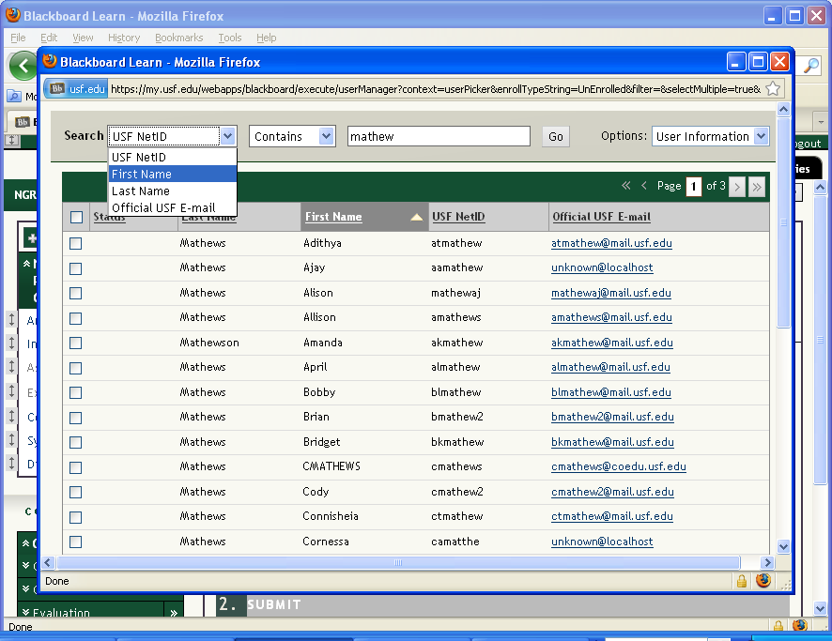

**From the search drop downlist select Last Name.Slide 5 - Slide 5**

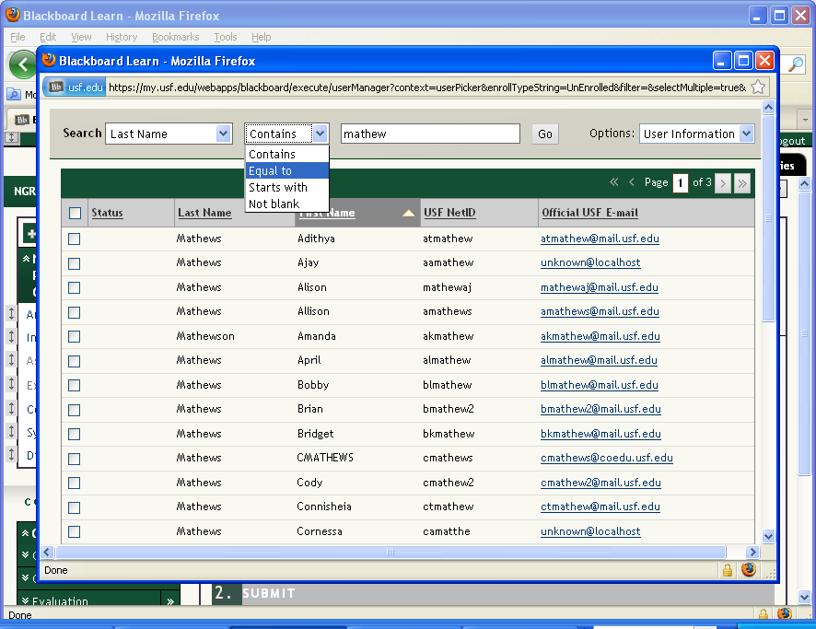

**From the second box, select Contains, if you are not sure of the full name or Equal to, if you have the full exact name of the user you are adding.Slide 6 - Slide 6**

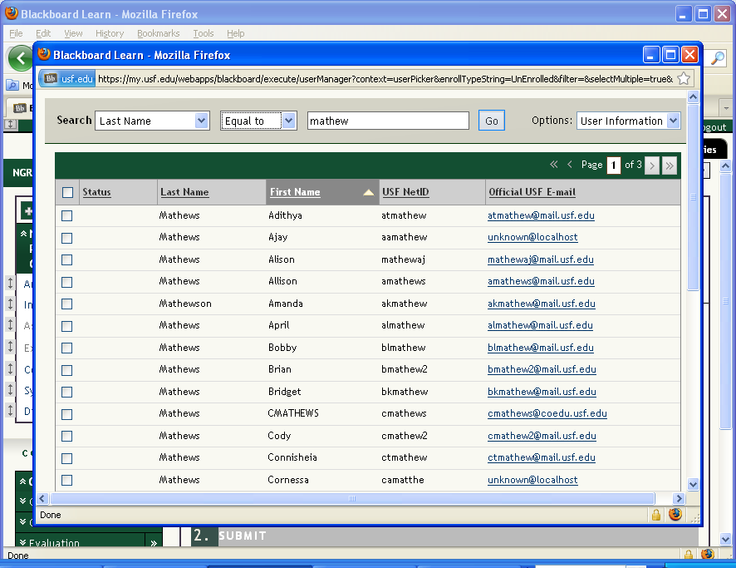

**Enter the individual’s name in the text field and click Go**

**Slide 8 - Slide 8**

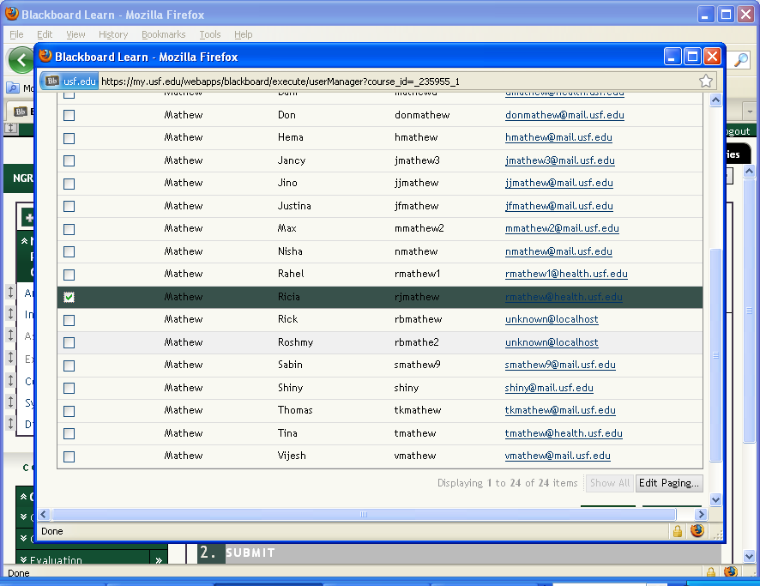

**Check the box that corresponds to the user’s name.Slide 9 - Slide 9**

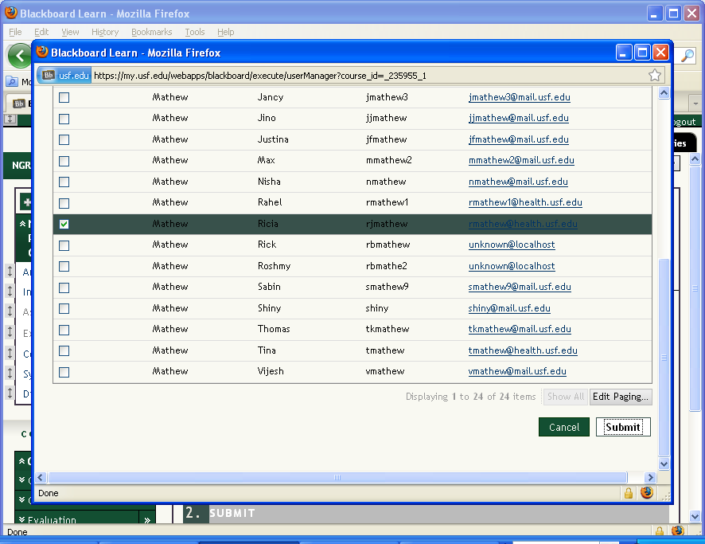

**Click the Submit button.Slide 10 - Slide 10**

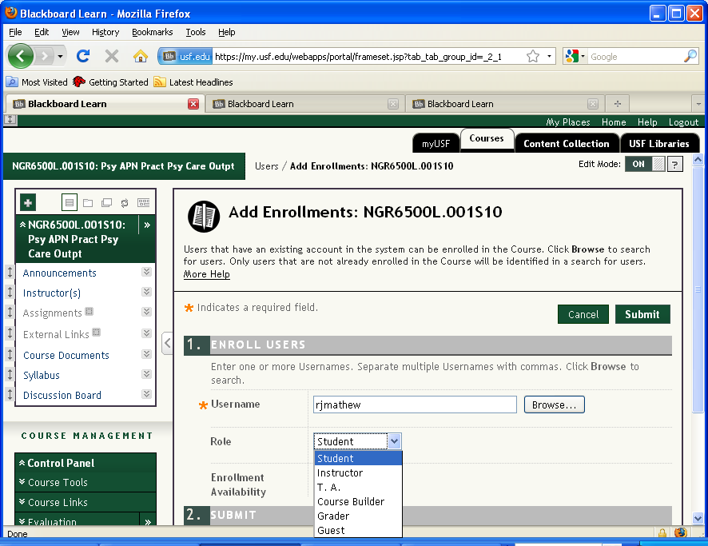

**From the Role drop-down list, indicate the user’s role in the course.Slide 11 - Slide 11**

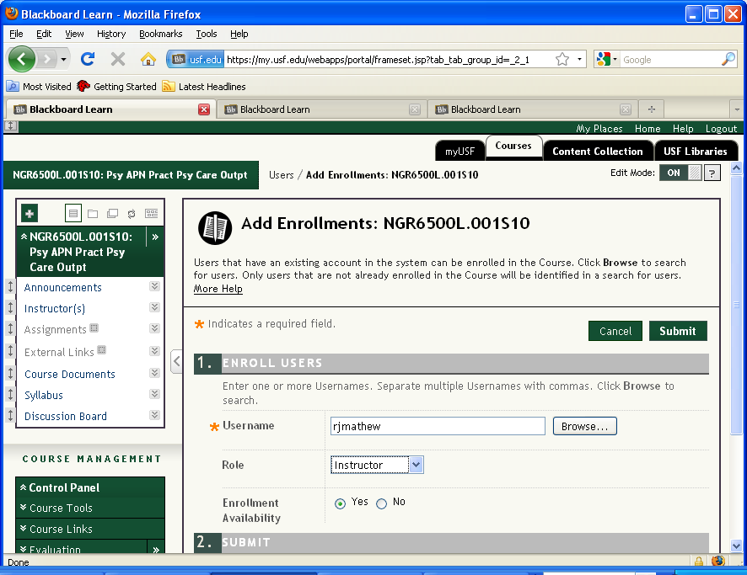

**Slide 12 - Slide 12**

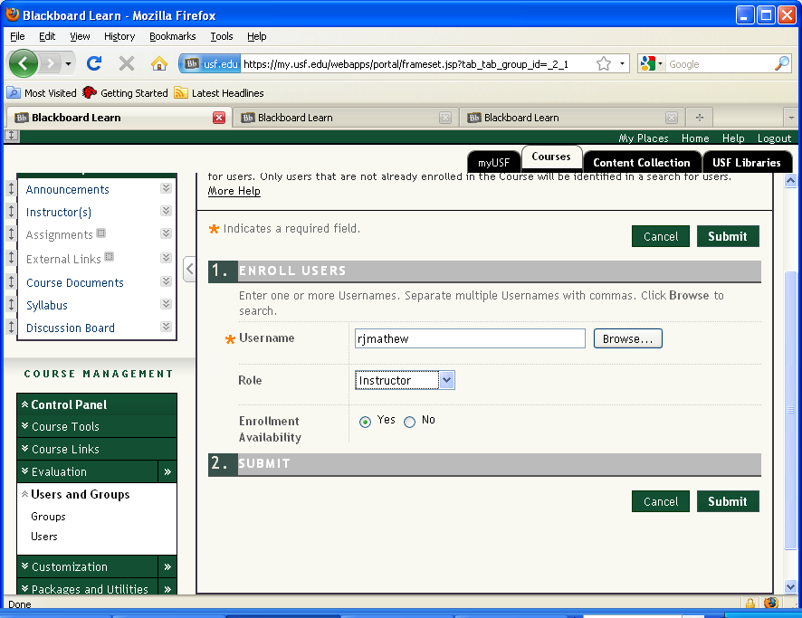

**Click Submit to complete the enrollment.Slide 13 - Slide 13**

